### ****Acknowledgement****

I would like to express my sincere gratitude to **Shashi Sir** and **Shashi Infotecs** for their invaluable guidance and support throughout the development of the “**ONLINE HOTEL BOOKING SYSTEM”** project. His expertise, patience, and constant encouragement played a pivotal role in helping me complete this project successfully.

Shashi Sir's insightful suggestions and direction helped me in understanding the complexities of web development and ensured that the project was designed in a way that meets both the functional and security requirements. His hands-on approach, feedback, and technical assistance significantly improved the quality of the final product.

I am truly grateful for the opportunity to work under his mentorship, which has enhanced my knowledge and skills in web development. Without his support, this project would not have been possible.

I would also like to thank everyone who helped and supported me in this journey.

Thank you, **Shashi Sir**, for being an integral part of this project!

DULARI KUMARI

(B.Tech [C.S.E] )

RKDF University , Ranchi

**ABSTRACT**

Abstract

The Online Hotel Booking System is a web-based application designed to facilitate easy and efficient booking of hotel rooms for customers. The system allows users to search for hotels based on location, price, and rating, and make bookings online. The project aims to provide a user-friendly interface, secure payment gateway, and real-time booking confirmation. The system will also enable hotel administrators to manage room availability, pricing, and bookings. The project will be developed using [insert technologies, e.g., HTML, CSS, MySQL], with a focus on scalability, reliability, and performance. The Online Hotel Booking System will provide a convenient and hassle-free booking experience for customers, while also streamlining hotel management operations..

**CONTENTS**

1. **INTRODUCTION**
   1. INTRODUCTION TO PROJECT
   2. PURPOSE OF THE PROJECT
2. **SYSTEM ANALYSIS**
   1. INTRODUCTION
   2. STUDY OF THE SYSTEM
   3. HARDWARE & SOFTWARE REQUIRMENT
   4. PROPOSED SYSTEM
   5. INPUT & OUTPUT
3. **FEASIBILITY REPORT**
   1. TECHNICAL FEASIBILITY
   2. OPERATIONAL FEASIBILITY
   3. ECONOMIC FEASIBILITY
4. **SOFTWARE REQUIREMENT SPECIFICATIONS**
   1. FUNCIONAL REQUIREMENTS
   2. PERFORMANCE REQUIREMENTS
5. **SELECTED SOFTWARE**
   1. INTRODUCTION TO VS CODE
   2. Apache Tomcat WebServer
   3. SQL
6. **SYSTEM DESIGN**
   1. INTRODUCTION
   2. SYSTEM WORKFLOW
   3. NUMBER OF MODULES
   4. SCOPE OF THE PROJECT
7. **SYSTEM SECURITY**
8. **CODE AND OUTPUT**
9. **CONCLUSION**
10. **BIBLIOGRAPHY**

**ONLINE HOTEL BOOKING SYSYTEM**

# 1. Introduction

**1.1 Introduction of the Project**

In today's fast-paced world, the hospitality industry is rapidly evolving, and the demand for seamless, user-friendly digital solutions is at an all-time high. The **Online Hotel Booking System** is designed to simplify and enhance the process of booking accommodations for travelers worldwide. This web-based platform allows users to search, compare, and reserve hotel rooms online from the comfort of their homes or on the go.

This project aims to provide a comprehensive solution for hotel bookings by integrating real-time availability checks, secure payment gateways, and detailed information about various hotels. The system is designed to cater to both the needs of hotel customers and hotel administrators. For guests, it offers a seamless experience for searching rooms, checking prices, reading reviews, and making bookings effortlessly. For hotel administrators, it provides an easy-to-use dashboard to manage room availability, bookings, and customer data.

Through this project, we aim to create a platform that improves efficiency, enhances customer satisfaction, and promotes a more convenient way of managing hotel reservations. Whether it’s a business trip, a family vacation, or a spontaneous getaway, the Online Hotel Booking System aims to be the go-to solution for travelers and hoteliers alike.

**1.2 Purpose of the project**

The purpose of this project is to design and develop a web-based Online Hotel Booking System that provides a convenient, efficient, and secure way for customers to book hotel rooms online. The system aims to:

1. **Simplify the hotel booking process:**

For customers, reducing the time and effort required to search and book hotel rooms.

**2. Increase hotel revenue:**

By providing a platform for hotel owners to promote their hotels and manage bookings more efficiently.

**3. Improve customer satisfaction :**

By offering a user-friendly interface, real-time booking confirmation, and secure payment processing.

**4. Reduce administrative tasks:**

For hotel owners, allowing them to focus on providing better services to their customers.

**2. System Analysis**

**2.1**

**System Analysis**

**1. Functional Requirements**

**1. User Registration : Users can register and create an account.**

**2. Hotel Search : Users can search for hotels based on location, price, and rating.**

**3. Room Booking : Users can book rooms online.**

**4. Payment Processing : Secure payment processing for online bookings.**

**5. Booking Confirmation : Real-time booking confirmation.**

**6. Hotel Management : Hotel owners can manage room availability, pricing, and bookings.**

**7. User Profile Management : Users can manage their profile and booking history.**

**2. Non-Functional Requirements:**

**1. Security : Ensure secure payment processing and protect user data.**

**2. Usability : User-friendly interface for easy navigation and booking.**

**3. Performance : Fast and efficient booking process.**

**4. Scalability : System can handle increased traffic and bookings.**

**5. Reliability : System is available 24/7 with minimal downtime.**

**3. System Components:**

**1. User Interface : Web-based interface for users to interact with the system.**

**2. Database : Stores hotel and room information, user data, and booking history.**

**3. Payment Gateway : Secure payment processing system.**

**4. Hotel Management System : Allows hotel owners to manage room availability, pricing, and bookings.**

**4. System Architecture:**

**1. Client-Server Architecture : Users interact with the system through a web-based interface, and the server processes requests and stores data.**

**2. Database Management System : MySQL or similar database management system to store and manage data.**

**5. System Design:**

**1. User Registration : Users can register through a simple form, and their data is stored in the database.**

**2. Hotel Search : Users can search for hotels based on location, price, and rating, and the system displays available hotels.**

**3. Room Booking : Users can book rooms online, and the system processes payment and confirms booking.**

**4. Hotel Management : Hotel owners can manage room availability, pricing, and bookings through a separate interface.**

**6. System Testing:**

**1. Unit Testing : Test individual components and functions.**

**2. Integration Testing : Test how components interact with each other.**

**3. System Testing : Test the entire system for functionality, performance, and security.**

**4. User Acceptance Testing : Test the system with real users to ensure it meets their needs.**

**2.2 STUDY OF THE SYSTEM**

**System Study**

* **System Overview:**

**The Online Hotel Booking System is a web-based application that allows users to search and book hotel rooms online. The system provides a user-friendly interface for users to interact with, and it processes bookings and payments securely.**

* **System Objectives**
* **Improve Customer Experience : Provide a user-friendly interface for customers to search and book hotel rooms online.**
* **Increase Hotel Revenue : Provide a platform for hotels to promote their rooms and increase bookings.**
* **Reduce Administrative Tasks : Automate booking and payment processes to reduce administrative tasks for hotels.**
* **System Scope:**
* **User Registration : Users can register and create an account.**
* **Hotel Search : Users can search for hotels based on location, price, and rating.**
* **Room Booking : Users can book rooms online.**
* **Payment Processing : Secure payment processing for online bookings.**
* **Booking Confirmation : Real-time booking confirmation.**
* **System Constraints:**
* **Security: Ensure secure payment processing and protect user data.**
* **Scalability : System must be able to handle increased traffic and bookings.**
* **Reliability : System must be available 24/7 with minimal downtime.**
* **System Assumptions:**
* **Internet Connectivity : Users have access to the internet to use the system.**
* **Payment Gateways : Secure payment gateways are available for online payments.**
* **System Limitations:**
* **Technical Issues : System may experience technical issues such as downtime or slow performance.**
* **Security Breaches : System may be vulnerable to security breaches such as hacking or data theft.**
* **System Implementation:**
* **Development : Develop the system using web development frameworks and databases.**
* **Testing : Test the system for functionality, performance, and security.**
* **Deployment : Deploy the system on servers and make it available to users.**
* **System Maintenance:**
* **Regular Updates : Regularly update the system with new features and security patches.**
* **Monitoring : Monitor the system for performance and security issues.**
* **Backup : Regularly backup system data to prevent data loss.**

#### ****System Flow and Workflow:****

* **User Registration:**

1. User visits the website and clicks on "Register"

2. User fills out the registration form with personal details

3. User submits the form and receives a confirmation email

4. User verifies their email address and logs in to the system

* **Hotel Search:**

1. User logs in to the system and clicks on "Search Hotels"

2. User enters search criteria (location, dates, etc.)

3. System displays a list of available hotels matching the search criteria

4. User selects a hotel and views its details (price, amenities, etc.)

* **Room Booking :**

1. User selects a room type and number of nights

2. System displays the total cost and payment options

3. User selects a payment option and enters payment details

4. System processes the payment and confirms the booking

**4. Booking Confirmation:**

1. System sends a confirmation email to the user

2. User receives the email and reviews the booking details

3. User can cancel or modify the booking through the system

**Workflow :**

* **User Workflow:**

1. Register on the system

2. Search for hotels

3. Select a hotel and room type

4. Book the room and pay online

5. Receive booking confirmation

* **Hotel Workflow:**

1. Register on the system

2. Add hotel details and room types

3. Set room prices and availability

4. Receive booking requests and confirm bookings

5. Update room availability and prices

* **Administrator Workflow:**

1. Manage user accounts and hotel listings

2. Monitor booking requests and payments

3. Update system settings and configurations

4. Generate reports on bookings and revenue

5. Provide customer support and resolve issues

**2.3.HARDWARE AND SPECIFICATIONS**

**HARDWARE REQUIREMENTS:**

* P i-5 ,2.8 GHz Processor and Above
* RAM 8 GB and Above
* HDD 500 GB Hard Disk Space and Above

**SOFTWARE REQUIREMENTS:**

* WINDOWS OS (windows 10/11)
* VS CODE
* Apache Tomcat Web Server
* SQL Database or MS Access

**2.4 PROPOSED SYSTEM**

The development of the new system contains the following activities, which try to automate the entire process keeping in view of the database integration approach.

* User friendliness is provided in the application with various controls.
* The system makes the overall project management much easier and flexible.
* It can be accessed over the Internet.
* Various classes have been used to provide file upload and mail features.
* There is no risk of data mismanagement at any level while the project development is under process.

**2.5 INPUT AND OUTPUT**

**INPUT DESIGN**

Input design is a part of overall system design. The main objective during the input design is as given below:

* To produce a cost-effective method of input.
* To achieve the highest possible level of accuracy.
* To ensure that the input is acceptable and understood by the user.

**INPUT TYPES:**

It is necessary to determine the various types of inputs. Inputs can be categorized as follows:

* External inputs, which are prime inputs for the system.
* Internal inputs, which are user communications with the system.
* Operational, which are computer department’s communications to the system?
* Interactive, which are inputs entered during a dialogue.

Input data is to be the directly keyed in by the user, the keyboard can be considered to be the most suitable input device.

**OUTPUT DESIGN**

Outputs from computer systems are required primarily to communicate the results of processing to users. They are also used to provide a permanent copy of the results for later consultation. The various types of outputs in general are:

* External Outputs, whose destination is outside the organization.
* Internal Outputs whose destination is with in organization and they are the
  + - User’s main interface with the computer.
* Operational outputs whose use is purely with in the computer department.
* Interface outputs, which involve the user in communicating directly with

**OUTPUT MEDIA:**

In the next stage it is to be decided that which medium is the most appropriate for the output. The main considerations when deciding about the output media are:

* The suitability for the device to the particular application.
* The need for a hard copy.
* The response time required.
* The location of the users
* The software and hardware available.

1. **FEASIBILITY REPORT**

Preliminary investigation examine project feasibility, the likelihood the system will be useful to the organization. The main objective of the feasibility study is to test the Technical, Operational and Economical feasibility for adding new modules and debugging old running system. All system is feasible if they are unlimited resources and infinite time. There are aspects in the feasibility study portion of the preliminary investigation:

1. Technical Feasibility
2. Operation Feasibility
3. Economical Feasibility

**3.1 Technical Feasibility:**

**Technical Feasibility Introduction:**

The Online Hotel Booking System project aims to develop a web-based application that enables users to search and book hotel rooms online. This technical feasibility report assesses the technical viability of the project, identifying potential technical risks, challenges, and opportunities. The report evaluates the technical requirements, infrastructure, and resources needed to develop and implement the system, providing recommendations for ensuring the project's technical success.

* **Technical Requirements**

- Programming Languages: HTML/CSS

- Database Management System: MySQL

* **Technical Feasibility:**

- Hardware Requirements: Web server, database server, etc.

- Software Requirements: Database management system.

* **Conclusion:**

The Online Hotel Booking System project is technically feasible. However, it requires careful planning and implementation to ensure security, scalability, and reliability.

* **Recommendations:**

- Conduct thorough security testing and vulnerability assessment

- Design the system to scale horizontally

- Implement secure payment processing and data encryption

**3.2 Operational Feaibility**

**Operational Feasibility Introduction**

**This operational feasibility report assesses the system's ability to meet business objectives, user needs, and operational requirements. The report evaluates the system's operational viability, including its impact on business processes, user acceptance, and operational efficiency. By examining these factors, this report provides insights into the operational feasibility of the Online Hotel Booking System and identifies potential areas for improvement.**

* **Operational Feasibility Report:**
* **Business Objectives:**

1. Increase bookings

2. Improve customer experience

3. Reduce administrative tasks

* **Operational Requirements**:

1. User management

2. Hotel management

3. Booking management

4. Customer support

* **Operational Viability**:

1. Business process integration

2. User acceptance

3. Operational efficiency

* **Operational Risks:**

1. System downtime

2. Security breaches

3. Integration issues

* **Conclusion:**

The Online Hotel Booking System project is operationally feasible. However, it requires careful planning and implementation to mitigate operational risks.

* **Recommendations:**

1. Conduct thorough operational testing

2. Implement regular system maintenance

3. Provide ongoing training to hotel staff

**3.3 Economical Feasibility**

**Economical Feasibility Introduction:**

**This economical feasibility report assesses the project's financial viability, evaluating its costs, benefits, and return on investment (ROI). The report provides a comprehensive analysis of the project's economic feasibility, helping stakeholders determine whether the project is a financially sound investment.**

* **Economical Feasibility Report:**

1**. Introduction**

The Online Hotel Booking System project aims to develop a web-based application that enables users to search and book hotel rooms online.

2. **Cost Estimation:**

* Development Costs : $100,000 - $150,000
* Infrastructure Costs : $10,000 - $20,000
* Marketing Costs : $20,000 - $30,000
* Maintenance Costs : $5,000 - $10,000 per year

**3. Revenue Estimation:**

* Commission-based Revenue : 10% - 15% of booking value
* Advertising Revenue : $10,000 - $20,000 per year
* Subscription-based Revenue: $5,000 - $10,000 per year

4**. Break-Even Analysis:**

* Break-Even Point : 6-12 months after launch
* Break-Even Revenue : $200,000 - $300,000 per year

**5. Return on Investment (ROI):**

* ROI : 15% - 25% per year
* Payback Period : 2-3 years

6**. Sensitivity Analysis:**

* Market Demand : A 10% increase in market demand will result in a 15% increase in revenue.
* Competition : A 10% increase in competition will result in a 5% decrease in revenue.

7. **Conclusion:**

The Online Hotel Booking System project is economically feasible. The project's estimated costs and revenue indicate a positive return on investment and a relatively short payback period.

8**. Recommendations:**

* Conduct thorough market research : To validate market demand and competition.
* Develop a comprehensive marketing strategy : To attract and retain customers.
* Monitor and adjust : Continuously monitor the project's financial performance and adjust strategies as needed.
  1. **SYSTEM REQUIRMENTSPECIFICATIONS**

**System Requirement Specification (SRS):**

1**. Introduction**

The Online Hotel Booking System is a web-based application that enables users to search and book hotel rooms online. This SRS document outlines the functional and non-functional requirements of the system.

**2. Functional Requirements:**

1**. User Management:**

- Users can register and login to the system.

- Users can update their profiles.

**2. Hotel Management:**

- Hotel administrators can add, edit, and delete hotel information.

- Hotel administrators can manage room availability and pricing.

**3. Booking Management :**

- Users can search for hotels and rooms.

- Users can book rooms online.

- Users can cancel or modify bookings.

**4. Payment Gateway :**

- The system integrates with a payment gateway for secure transactions.

**3. Non-Functional Requirements :**

**1. Performance:**

- The system responds to user requests within 2 seconds.

- The system can handle 100 concurrent users.

**2. Security:**

- The system uses SSL/TLS encryption for secure data transmission.

- The system stores passwords securely using hashing and salting.

**3. Usability :**

- The system has an intuitive user interface.

- The system provides clear and concise instructions for users.

**4. Interface Requirements:**

**1. User Interface :**

- The system uses HTML5, CSS, for the user interface.

- The system is compatible with major web browsers.

**2. Application Programming Interface (API):**

- The system provides a RESTful API for integrating with third-party services.

**5. Data Requirements:**

**1. Data Storage :**

- The system uses a relational database management system (RDBMS) for data storage.

- The system stores user data, hotel data, and booking data.

**2. Data Backup and Recovery :**

- The system performs regular backups of data.

- The system has a disaster recovery plan in place.

6. Conclusion:

This SRS document outlines the functional and non-functional requirements of the Online Hotel Booking System. The system must meet these requirements to ensure it is functional, secure, and user-friendly.

**4.2 PERFORMANCE REQUIREMENTS:**

Performance is measured in terms of the output provided by the application. Requirement specification plays an important part in the analysis of a system. Only when the requirement specifications are properly given, it is possible to design a system, which will fit into required environment. It rests largely in the part of the users of the existing system to give the requirement specifications because they are the people who finally use the system. This is because the requirements have to be known during the initial stages so that the system can be designed according to those requirements. It is very difficult to change the system once it has been designed and on the other hand designing a system, which does not cater to the requirements of the user, is of no use.

The requirement specification for any system can be broadly stated as given below:

* The system should be able to interface with the existing system
* The system should be accurate
* The system should be better than the existing system

The existing system is completely dependent on the user to perform all the duties.

# **5. SELECTED SOFTWARE**

**5.1 INTRODUCTION TO VS CODE**

**Visual Studio Code (VS Code)** is a lightweight yet powerful **source code editor** developed by Microsoft. It is widely used by developers for writing, debugging, and managing code efficiently. VS Code is an open-source editor available for **Windows, macOS, and Linux**, making it a versatile choice for programmers across different platforms.

VS Code supports multiple **programming languages** such as **Python, JavaScript, Java, C++, HTML, CSS**, and more. It comes with built-in **Git integration**, **IntelliSense (intelligent code completion)**, and a **debugging tool** to enhance coding productivity. Additionally, its **extensive marketplace** allows users to install extensions for additional functionalities like **linting, formatting, and AI-assisted coding**.

With features like **a customizable interface, integrated terminal, and real-time collaboration (Live Share)**, VS Code is one of the most popular and preferred editors for both beginners and experienced developers. It provides a seamless coding experience while maintaining high performance and efficiency.

# **5.2 Apache Tomcat Server**

**Apache Tomcat** is an open-source **web server and servlet container** developed by the **Apache Software Foundation (ASF)**. It is widely used for deploying and running **Java-based web applications** that utilize **Java Servlets, JavaServer Pages (JSP), and Java Expression Language (EL)**. Unlike traditional web servers that primarily handle static content, Tomcat provides a robust runtime environment for executing dynamic Java applications. It includes a built-in **HTTP server**, making it a complete solution for handling both static and dynamic requests efficiently.

Tomcat is known for being **lightweight, scalable, and cross-platform compatible**, running on operating systems like **Windows, macOS, and Linux**. It supports essential web security features such as **SSL/TLS encryption, role-based access control, and authentication mechanisms**, ensuring secure communication between clients and servers. Additionally, it can be customized through configuration files like **server.xml**, allowing developers to fine-tune its performance based on application requirements.

Commonly used for hosting **Java-based web applications, RESTful APIs, and Spring-based projects**, Apache Tomcat remains one of the most reliable and efficient servlet containers available. Its ability to balance **simplicity, flexibility, and performance** makes it an essential tool for developers working with Java web technologies.

**5.3 SQL 10g**

**SQL 10g** refers to **Oracle Database 10g**, a **relational database management system (RDBMS)** developed by **Oracle Corporation**. It is part of the Oracle 10g suite, where "g" stands for **grid computing**, highlighting its capability to efficiently distribute computing resources across multiple machines. Oracle 10g provides a robust environment for managing large-scale **structured data** with high performance, security, and reliability.

The **Oracle JDBC Thin Driver (ojdbc14.jar)** is a **pure Java driver** that allows Java applications to connect to an **Oracle 10g database** without requiring additional Oracle software on the client machine. It uses **TCP/IP** for direct database communication, making it a lightweight and platform-independent solution.

### ****Steps to Connect SQL 10g with Thin OJDBC 14 Driver****

#### ****1. Download and Install the OJDBC 14 Driver****

* Download the **ojdbc14.jar** file from the Oracle website or use the one provided with Oracle 10g.
* Place it in your **Java classpath** (e.g., lib folder in your project).

#### ****2. Import JDBC Package in Java****

import java.sql.Connection;

import java.sql.DriverManager;

import java.sql.ResultSet;

import java.sql.Statement;

#### ****3. Load the Oracle JDBC Thin Driver****

Class.forName("oracle.jdbc.driver.OracleDriver");

* This step loads the **Oracle JDBC Thin Driver** dynamically.

#### ****4. Establish a Connection****

Use the DriverManager.getConnection() method to connect to the database.

Connection con = DriverManager.getConnection(

"jdbc:oracle:thin:@localhost:1521:xe", "username", "password");

* **jdbc:oracle:thin:** → Specifies that we are using the Thin driver.
* **@localhost:1521:xe** → Database host, port, and service name (XE for Express Edition).
* **username and password** → Oracle database credentials.

#### ****5. Execute SQL Queries****

Statement stmt = con.createStatement();

ResultSet rs = stmt.executeQuery("SELECT * FROM students");

while (rs.next()) {

System.out.println(rs.getInt(1) + " " + rs.getString(2));

}

* This example retrieves and prints data from a **students** table.

#### ****6. Close the Connection****

rs.close();

stmt.close();

con.close();

**6. SYSTEM DESIGN**

**6.1 System Design Introduction**

**This system design document outlines the overall architecture, components, and interactions of the system, providing a comprehensive guide for developers, stakeholders, and users. The design aims to ensure scalability, reliability, and maintainability, while meeting the functional and non-functional requirements of the system.**

**1. Architecture:**

The system will follow a microservices architecture, with the following components:

Presentation Layer : Handles user interactions and displays data.

Application Layer : Handles business logic and integrates with other services.

Data Access Layer : Handles data storage and retrieval.

**2. Components:**

1. User Service :

Handles user registration, login, and profile management.

Integrates with the Authentication Service for secure authentication.

**2. Hotel Service**:

Handles hotel information management, including room availability and pricing.

Integrates with the *Payment Gateway* for secure transactions.

**3. Booking Service :**

Handles booking management, including searching, booking, and canceling rooms.

Integrates with the *Hotel Service* and *Payment Gateway*.

**4. Payment Gateway:**

Handles secure payment processing.

**5. Database :**

Stores user data, hotel data, and booking data.

**3. Data Flow:**

1. User Registration :

- User submits registration form.

- User Service validates form data and creates user account.

- User Service stores user data in *Database*.

2. Hotel Search :

- User submits search query.

- Booking Service retrieves hotel data from *Hotel Service*.

- Booking Service displays search results to user.

3. Booking:

- User selects hotel room and submits booking form.

- Booking Service validates form data and creates booking.

- Booking Service integrates with *Payment Gateway* for secure payment processing.

4. Payment Processing:

- Payment Gateway processes payment.

- Payment Gateway notifies *Booking Service* of payment result.

**4. Technology Stack:**

1. Frontend:

- HTML5

- CSS

- JavaScript

-

2. *Backend*:

- Java

3. *Database*:

- Relational database management system (RDBMS) such as MySQL or PostgreSQL

**5. Security:**

1. Authentication :

Uses JSON Web Tokens (JWT) for secure authentication.

2. Authorization :

Uses role-based access control (RBAC) to restrict access to sensitive data.

3. Data Encryption :

- Uses SSL/TLS encryption for secure data transmission.

4. Password Storage :

- Stores passwords securely using hashing and salting.

**6. Scalability:**

1. Horizontal Scaling :

Uses load balancing to distribute traffic across multiple servers.

2. Vertical Scaling :

Uses cloud providers to scale up or down as needed.

3. Caching:

Uses caching mechanisms to reduce database queries and improve performance.

**Database Design**

|  |  |
| --- | --- |
| Table | Description |
| customer | Maintains student academic records and resumes. |
| hotel | Maintains Company Details |

**Technology Stack**

|  |  |
| --- | --- |
| Layer | Technology used |
| Frontend | Html,Css,Javascript |
| Backend | Jsp(Java) |
| Database | SQL 10g |
| Hosting | Apache Tomcat Webserver(Local Server) |

# 

# **6.2 System Workflow**

The **System Workflow** defines the sequence of processes and interactions that take place within the **Placement Portal**. It outlines how users—students, recruiters, and placement officers—interact with the system, and how data flows between different modules. The system workflow ensures smooth functionality, seamless transitions between steps, and an efficient user experience.

Below is the **system workflow** divided into different user interactions:

**Homepage**

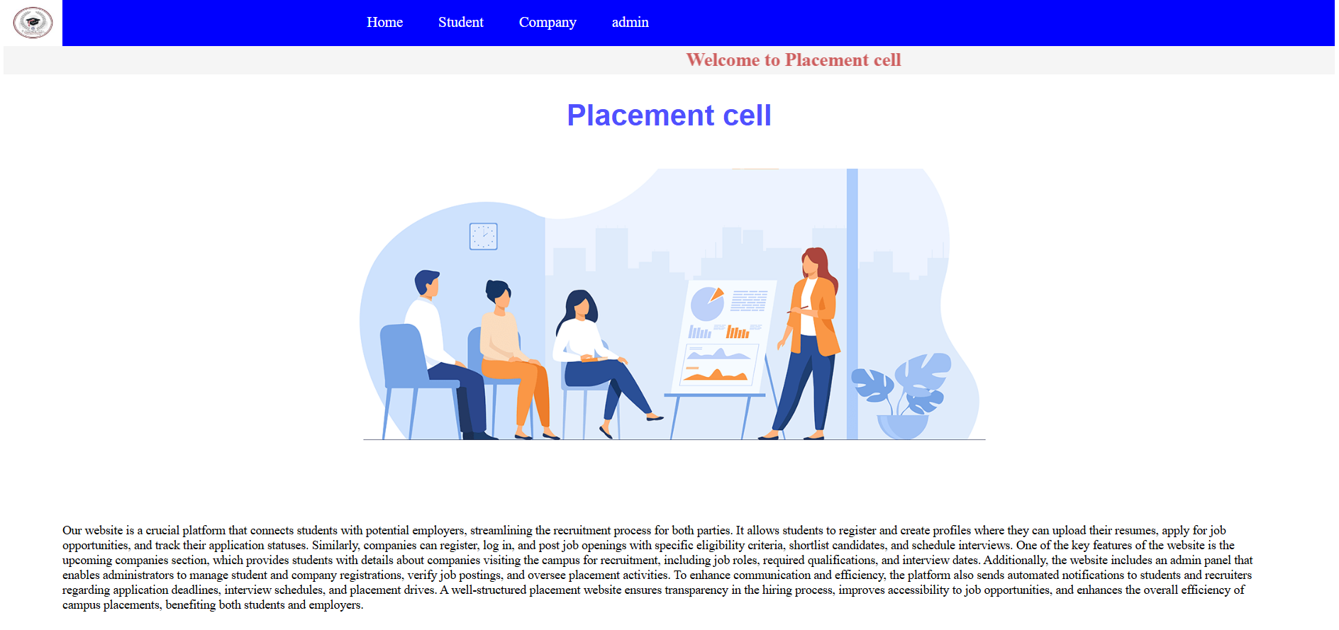

# 

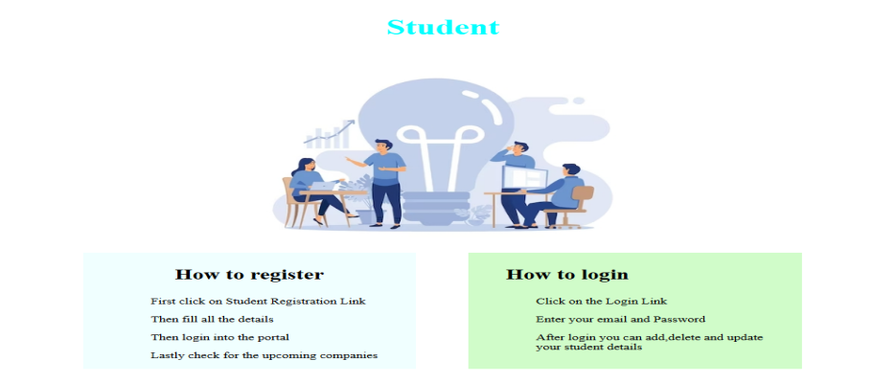

# 

# **Student Login and Registration**

# 

# 

# **Company Login and Registration**

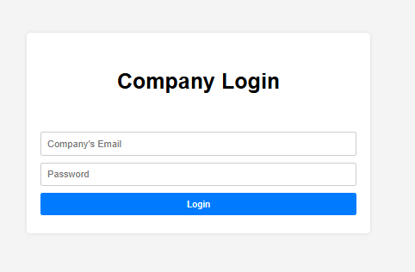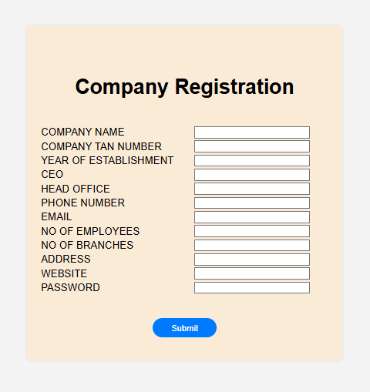

# **Admin Dashboard**

# 

# **6.3 NUMBER OF MODULES**

The modules involved are:

**Modules**

* + 1. **User Module :**

Handles user registration, login, and profile management.

* + 1. **Hotel Module:**

Handles hotel registration, listing, and management.

* + 1. **Room Module:**

Handles room availability, pricing, and management.

* + 1. **Search Module:**

Handles search functionality for hotels and rooms.

* + 1. **Booking Module:**

Handles booking processing, payment gateway integration, and booking management.

* + 1. **Admin** **Module**:

Handles administrative tasks, such as user management, hotel management, and booking management.

**6.4 SCOPE OF THE PROJECT**

**Scope Statement**

**1. Project Overview:**

The Online Hotel Booking System project aims to design and develop a web-based application that enables users to search and book hotel rooms online.

**2. Scope:**

The scope of this project includes:

1. User Registration and Management : Develop a user registration system, allowing users to create and manage their accounts.

2. Hotel Registration and Management : Develop a hotel registration system, allowing hotel administrators to create and manage their hotel listings.

3. Room Availability and Pricing : Develop a system to manage room availability and pricing in real-time.

4. Search and Booking : Develop a search engine to allow users to search for hotels and rooms based on their preferences, and a booking system to process bookings.

5. Booking Management : Develop a system to allow users and hotel administrators to view and manage bookings.

6. Cancellation and Refund : Develop a system to handle cancellations and refunds.

**3. Out of Scope:**

The following items are out of scope for this project:

1. Hotel Management System : The project will not include a comprehensive hotel management system.

2. Customer Relationship Management : The project will not include a customer relationship management system.

3. Integration with External Systems : The project will not include integration with external systems, such as property management systems or revenue management systems.

**4. Assumptions and Dependencies**:

The project assumes that:

1. The payment gateway integration will be completed within the project timeline.

2. The hotel administrators will provide accurate and up-to-date information about their hotels and rooms.

The project depends on:

1. The availability of the payment gateway API.

2. The cooperation of hotel administrators in providing accurate and up-to-date information.

**7 . System Security**

**System Security Plan**

**1. Introduction:**

**The Online Hotel Booking System requires a robust security plan to protect user data, prevent unauthorized access, and ensure the integrity of the system.**

**2. Security Objectives:**

**1. Confidentiality : Protect user data and sensitive information from unauthorized access.**

**2. Integrity: Ensure the accuracy and completeness of user data and system information.**

**3. Availability : Ensure the system is accessible and usable by authorized users.**

**3. Security Measures:**

**1. Authentication : Implement secure authentication mechanisms, such as password hashing and salting.**

**2. Authorization : Implement role-based access control (RBAC) to restrict access to sensitive data and system functionality.**

**3. Data Encryption : Use SSL/TLS encryption to protect data in transit.**

**4. Firewall : Configure firewalls to restrict incoming and outgoing traffic.**

**5. Intrusion Detection and Prevention : Implement intrusion detection and prevention systems to detect and prevent unauthorized access.**

**6. Regular Updates and Patching : Regularly update and patch the system to prevent exploitation of known vulnerabilities.**

**4. User Account Security:**

**1. Password Policy : Enforce a strong password policy, including password length, complexity, and expiration.**

**2. Account Lockout : Implement account lockout policies to prevent brute-force attacks.**

**3. Session Management : Implement secure session management practices, including secure cookie management.**

**5. Data Protection:**

**1. Data Backup : Regularly backup user data and system information.**

**2. Data Storage : Store sensitive data, such as credit card numbers, securely using encryption and access controls.**

**6. Incident Response:**

**1. Incident Response Plan : Develop and implement an incident response plan to handle security incidents.**

**2. Incident Reporting : Establish procedures for reporting security incidents.**

**7. Compliance:**

**1. Regulatory Compliance : Ensure compliance with relevant regulatory requirements, such as PCI-DSS and GDPR.**

**2. Industry Standards : Adhere to industry standards, such as OWASP and NIST.**

**8. CODE AND OUTPUT**

**Homepage(index.html)**

<html>

<head>

<div class="menubar">

<img src="logo.png" alt="">

<li><a href="index.html">Home</a><li>

<li>

<a href="#">Student </a>

<ul class="submenu">

<li><a href="studentregistration.html" >Student Registration</a></li>

<li><a href="studentlogin.html" > Student Login</a></li>

</ul>

<li>

<li>

<a href="#">Company</a>

<ul class="submenu">

<li><a href="companyregistration.html" >Company Registration</a></li>

<li><a href="companylogin.html" > Company Login</a></li>

<li><a href="upcomingcompany.html" > Upcoming Company Registration</a></li>

</ul>

<li>

<li><a href="adminlogin.html">admin</a><li>

</div>

</head>

<body>

<div class="main">

<marquee behavior="scroll" direction="right" bgcolor="whitesmoke"><h1>Welcome to Placement cell</h1></marquee>

<h2>Placement cell</h2><br>

<center><img src="placement.png" alt=""></center><br>

<p>Our website is a crucial platform that connects students with potential employers, streamlining the recruitment process for both parties. It allows students to register and create profiles where they can upload their resumes, apply for job opportunities, and track their application statuses. Similarly, companies can register, log in, and post job openings with specific eligibility criteria, shortlist candidates, and schedule interviews. One of the key features of the website is the upcoming companies section, which provides students with details about companies visiting the campus for recruitment, including job roles, required qualifications, and interview dates. Additionally, the website includes an admin panel that enables administrators to manage student and company registrations, verify job postings, and oversee placement activities. To enhance communication and efficiency, the platform also sends automated notifications to students and recruiters regarding application deadlines, interview schedules, and placement drives. A well-structured placement website ensures transparency in the hiring process, improves accessibility to job opportunities, and enhances the overall efficiency of campus placements, benefiting both students and employers.</p>

<div class="submain" style="background-color: rgba(250, 235, 215, 0.489);padding: 12px 20px;"><h3>Key Features</h3>

<li>Student Registration & Login – Students can create an account, upload their resumes, and apply for job openings. They can also track application statuses and receive notifications about upcoming companies.</li>

<li>Company Registration & Login – Companies can register, post job openings, set eligibility criteria, and shortlist candidates. They can also schedule interviews and update hiring statuses.</li>

<li>Upcoming Companies Section – Displays details of companies visiting the campus for recruitment, including job roles, required qualifications, and interview dates.</li>

<li>Admin Panel – A centralized dashboard for administrators to manage student and company registrations, verify job postings, and ensure smooth placement processes.</li><br>

</div>

</div>

<div class="abvstud">

<center><h2>Student</h2></center>

<center><img src="student.png" alt=""></center>

</div>

<div class="student">

<section class="stud1" style="background-color: azure;padding: 0px 50px; margin-right: 70px;">

<center><h3 style="font-size: 30px;">How to register</h3></center>

<ul>First click on Student Registration Link</ul>

<ul>Then fill all the details</ul>

<ul>Then login into the portal </ul>

<ul>Lastly check for the upcoming companies</ul>

</section>

<section class="stud2" style="background-color: rgba(180, 251, 169, 0.626);padding: 0px 50px;">

<center><h3 style="font-size: 30px;margin-right: 180px;">How to login</h3></center>

<ul>Click on the Login Link</ul>

<ul>Enter your email and Password</ul>

<ul>After login you can add,delete and update <br> your student details</ul>

</section>

</div><br>

<div class="company">

<center><h2>Role of Company </h2></center>

<p>Companies play a crucial role in the placement process by providing job opportunities and shaping students' careers. Their primary responsibility is to register on the placement website and create a profile with relevant details about their industry, job openings, and hiring process. Once registered, they can post job vacancies with specific eligibility criteria, including required skills, qualifications, and experience levels.

A key role of companies is to shortlist candidates based on their applications and resumes. They may conduct various rounds of assessments such as aptitude tests, technical interviews, group discussions, and HR interviews to evaluate the students' abilities. Companies are also responsible for communicating interview schedules, selection results, and other important details to the candidates through the placement portal.</p>

<center><img src="company.png" alt=""></center>

<ul>Companies have to register first in the portal</ul>

<ul>They have to mention their requirements in the registration form itself</ul>

<ul>Interested company along with the students skill will be matched and <br> companies are needed to register in upcoming company link</ul>

</div>

<style>

.submenu {

list-style: none;

padding-left: 20px;

display: none;

}

.menubar li:hover .submenu {

display: block;

}

.submenu li {

padding: 4px;

}

.submenu li a {

color: #bdc3c7;

text-decoration: none;

}

.submenu li:hover {

background: #415b76;

}

.menubar {

display: flex;

background-color: blue;

}

.menubar li{

list-style-type: none;

padding: 25px 15px;

}

.menubar a{

color: white;

font-size: 25px;

text-align: center;

}

.menubar li a{

text-decoration: none;

}

.menubar a:hover{

color: crimson;

}

.menubar img{

height: 80px;

width: 100px;

margin-right: 500px;

}

.main h1{

margin: 5px;

color: indianred;

}.main h2{

text-align: center;

font-size: 50px;

color: rgb(80, 80, 255);

font-family: Arial, Helvetica, sans-serif;

}.main p{

font-size: 21px;

padding: 100px;

font-weight: 1px;

}

.submain h3{

font-size: 25px;

text-align: center;

color: rgba(255, 52, 52, 0.556);

}

.submain li{

font-size: 18px;

padding: 5px 50px;

}

.abvstud h2{

color: aqua;

font-size: 45px;

}

.student{

display: flex;

justify-content: center;

}

.stud1 ul{

font-size: 18px;

}

.stud2 ul{

font-size: 18px;

}

.main-footer{

display: flex;

background-color: aliceblue;

}

</style>

</body>

<footer>

<div class="main-footer">

<section class="footer1">

<center><h2>About us</h2></center>

<ul>Our placement portal connects students with top recruiters, ensuring a smooth hiring process for both candidates and companies.</ul>

</section>

<section class="footer2">

<center><h2>Quick Links</h2></center>

<li><a href="studentregistration.html">Student Registration</a></li>

<li><a href="studentlogin.html">Student login</a></li>

<li><a href="companyregistration.html">Company Registration</a></li>

<li><a href="companylogin.html">Company login</a></li>

<li><a href="upcomingcompany.html">Upcoming Company Registration</a></li>

<li><a href="upcomingcompanyview.jsp">Upcoming Companies info</a></li>

</section>

<section class="footer3">

<center><h2>Contact info</h2></center>

<ul>Email: abcd@gmail.com</ul>

<ul>Phone: </ul>

</section>

</div>

<center><p>All rights reserved to © Placemnt Cell</p></center>

</footer>

</html>

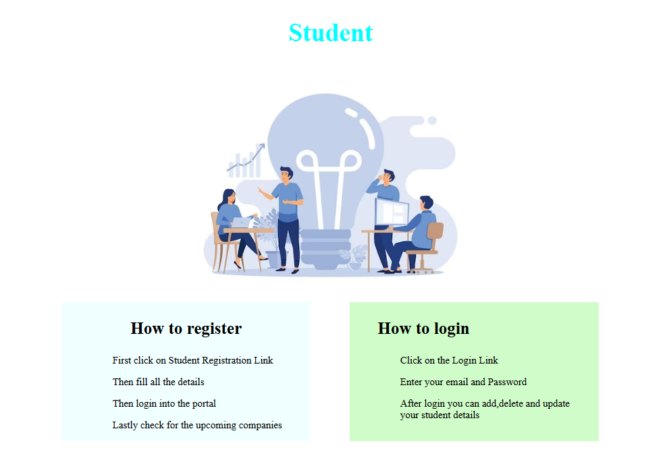

**Admin Dashboard(admindash.html)**

<!DOCTYPE html>

<html lang="en">

<head>

<meta charset="UTF-8">

<meta name="viewport" content="width=device-width, initial-scale=1.0">

<title>Admin Dashboard</title>

<style>

* {

margin: 0;

padding: 0;

box-sizing: border-box;

font-family: Arial, sans-serif;

}

body {

display: flex;

}

/* Sidebar Styles */

.sidebar {

width: 250px;

height: 100vh;

background: #2c3e50;

color: white;

padding: 20px;

}

.sidebar h2 {

text-align: center;

margin-bottom: 20px;

}

.menu {

list-style: none;

padding: 0;

}

.menu li {

padding: 10px;

cursor: pointer;

}

.menu li a {

color: white;

text-decoration: none;

display: block;

}

.menu li:hover {

background: #34495e;

}

/* Submenu */

.submenu {

list-style: none;

padding-left: 20px;

display: none;

}

.menu li:hover .submenu {

display: block;

}

.submenu li {

padding: 8px;

}

.submenu li a {

color: #bdc3c7;

text-decoration: none;

}

.submenu li:hover {

background: #415b76;

}

/* Main Content - Iframe */

.main-content {

flex: 1;

padding: 20px;

background: #ecf0f1;

}

iframe {

width: 100%;

height: 100vh;

border: none;

}

</style>

</head>

<body>

<div class="sidebar">

<h2>Admin Dashboard</h2>

<ul class="menu">

<li><a href="adminmaindash.html" target="content-frame">Dashboard</a></li>

<li>

<a href="#">Student Management</a>

<ul class="submenu">

<li><a href="studentadd.html" target="content-frame"> Student Add</a></li>

<li><a href="studupdate.html" target="content-frame">Student Update</a></li>

<li><a href="studelete.html" target="content-frame">Student Delete</a></li>

<li><a href="searchstud.html" target="content-frame"> Student Search</a></li>

<li><a href="studentdashboard.jsp" target="content-frame"> View all Student</a></li>

</ul>

</li>

<li>

<a href="#">Company Management</a>

<ul class="submenu">

<li><a href="companyadd.html" target="content-frame">Add company</a></li>

<li><a href="compupdate.html" target="content-frame">Company update</a></li>

<li><a href="compdelete.html" target="content-frame"> Company delete</a></li>

<li><a href="searchcompany.html" target="content-frame">search Company </a></li>

<li><a href="companydashboard.jsp" target="content-frame">View all Registered <br> companies</a></li>

<li><a href="upcomingcompany.html" target="content-frame">Upcoming Companies Registration</a></li>

<li><a href="upcomingcompanyview.jsp" target="content-frame">Upcoming Companies </a></li>

</ul>

</li>

<li><a href="logout.html" target="content">Logout</a></li>

</ul>

</div>

<div class="main-content">

<iframe name="content-frame" src="adminmaindash.html"></iframe>

</div>

</body>

</html>

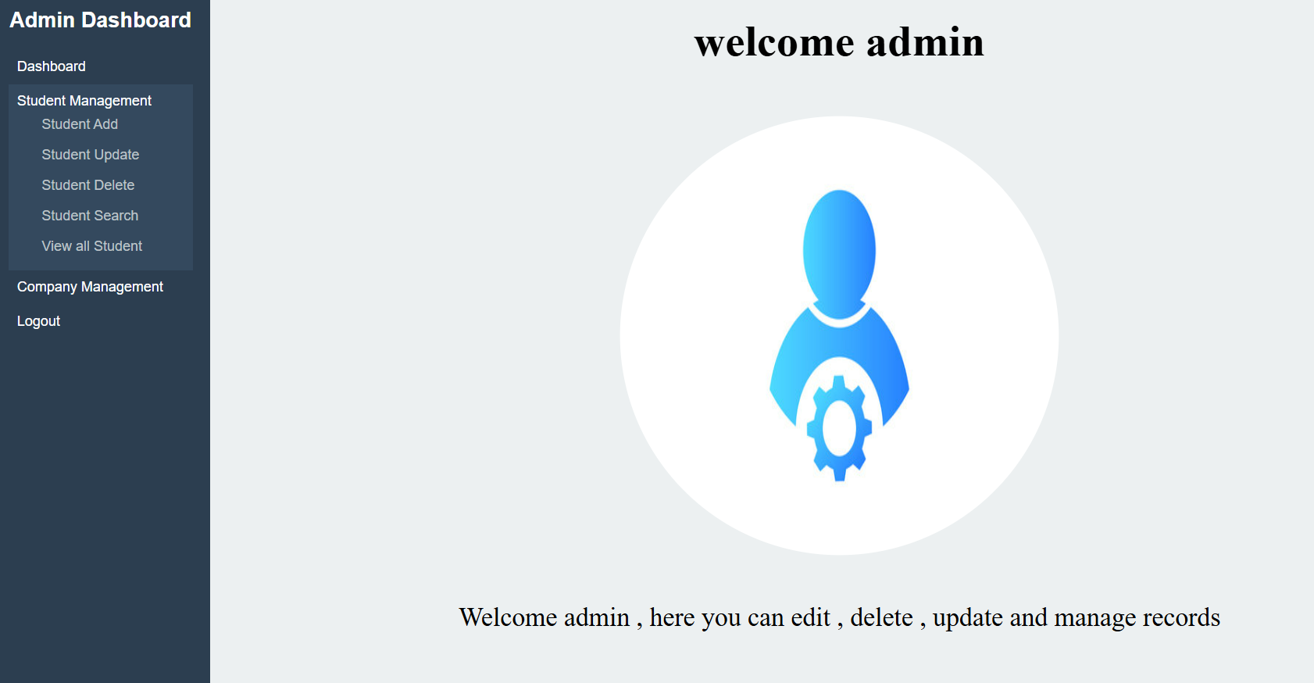

**Admin login (admin.html and admin.jsp)**

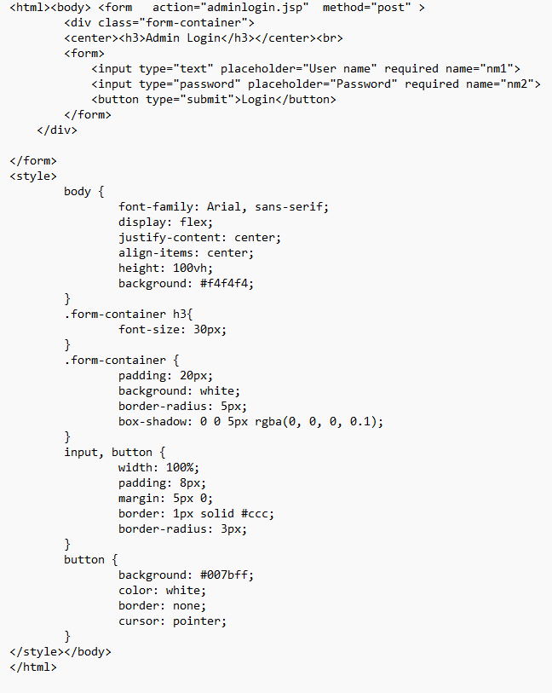

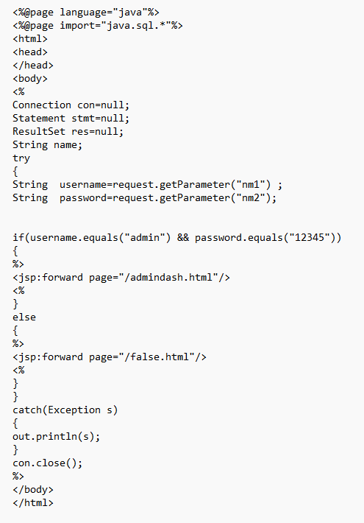

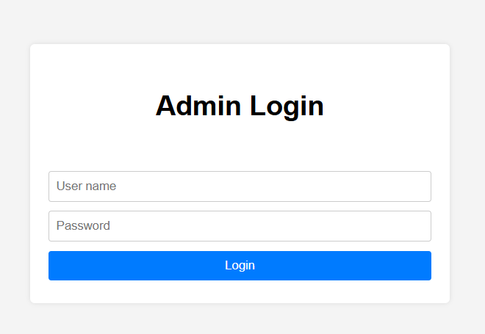

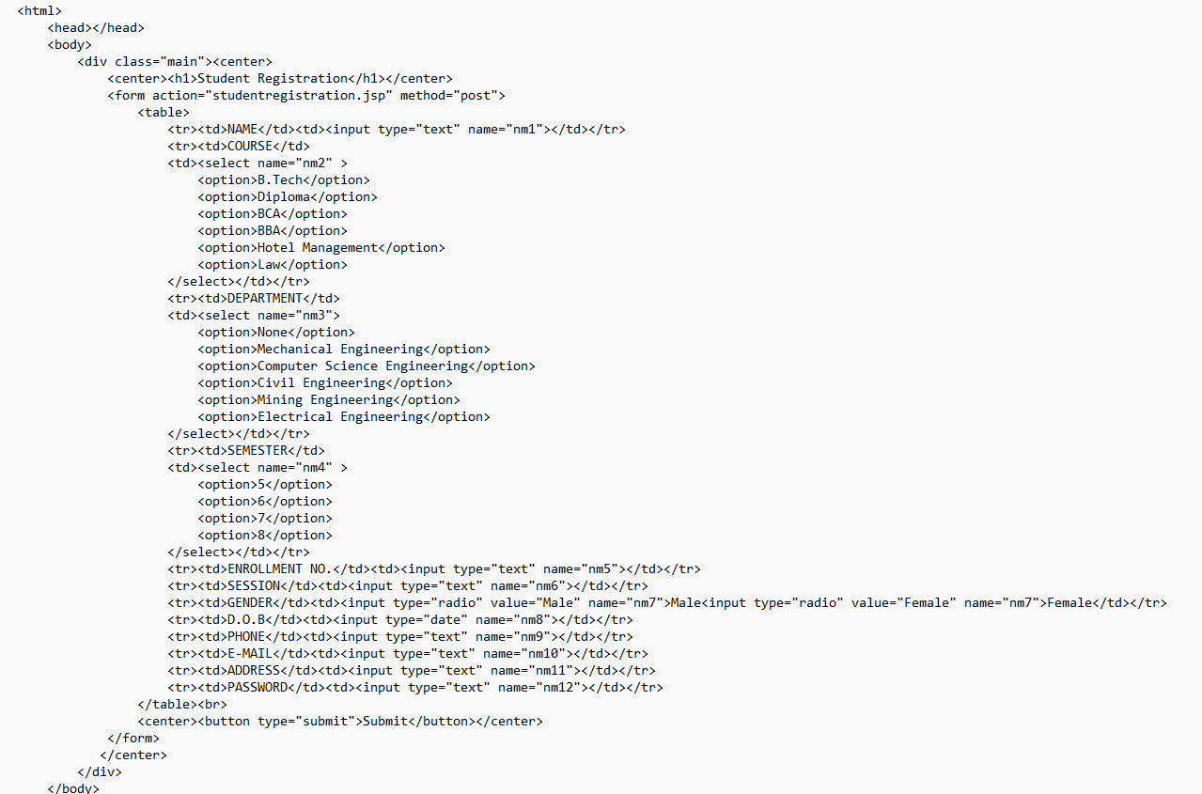**Student registration(student registration.html )**

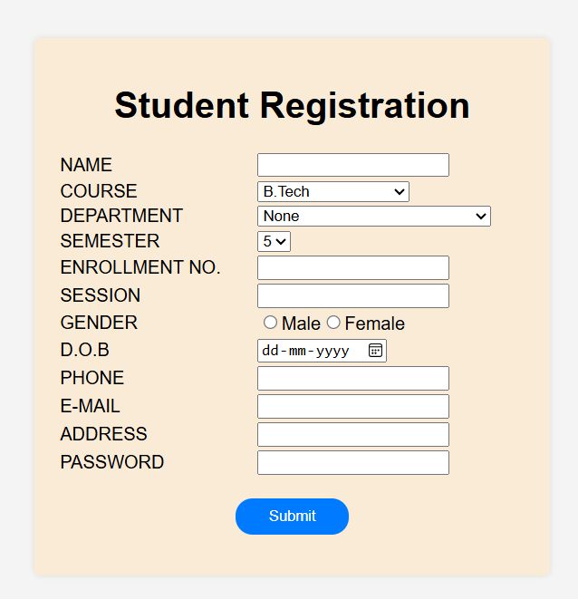

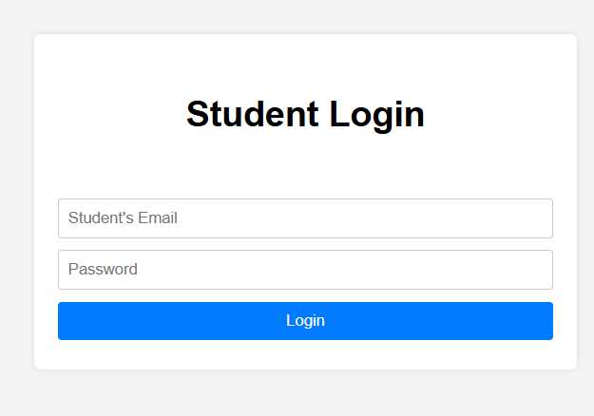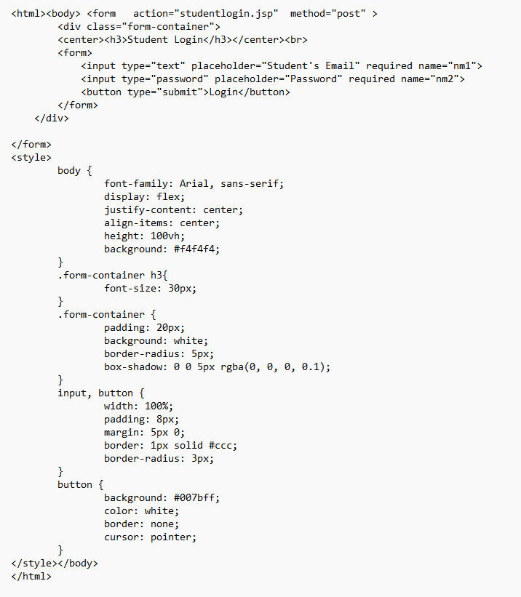

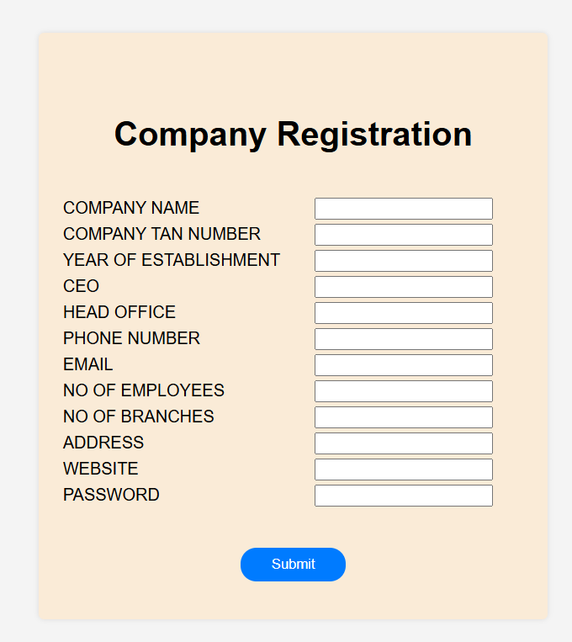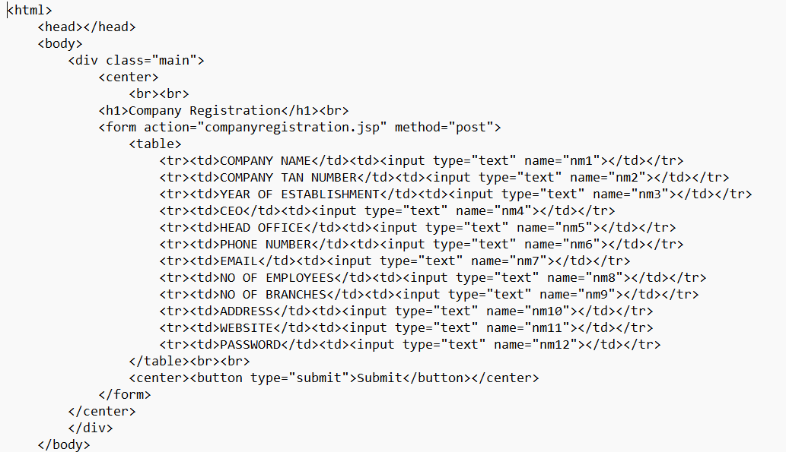

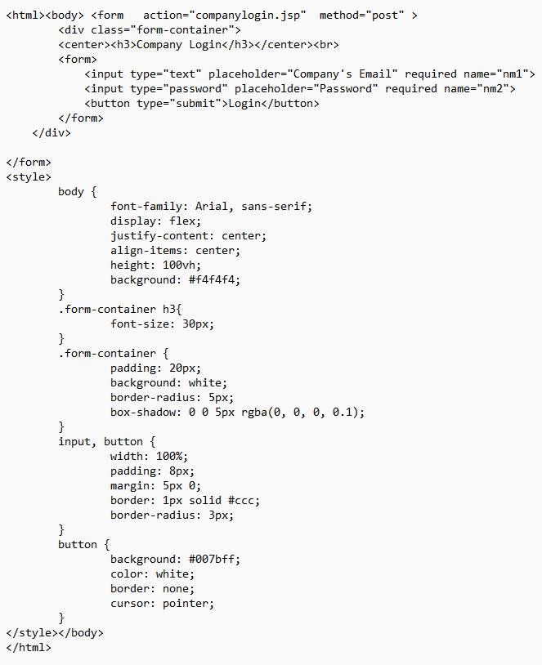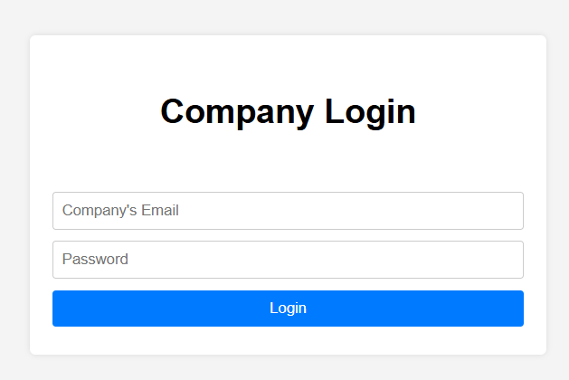

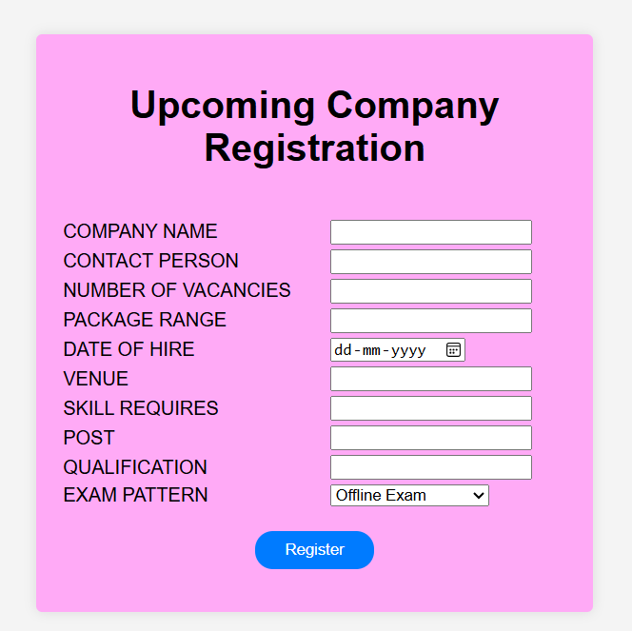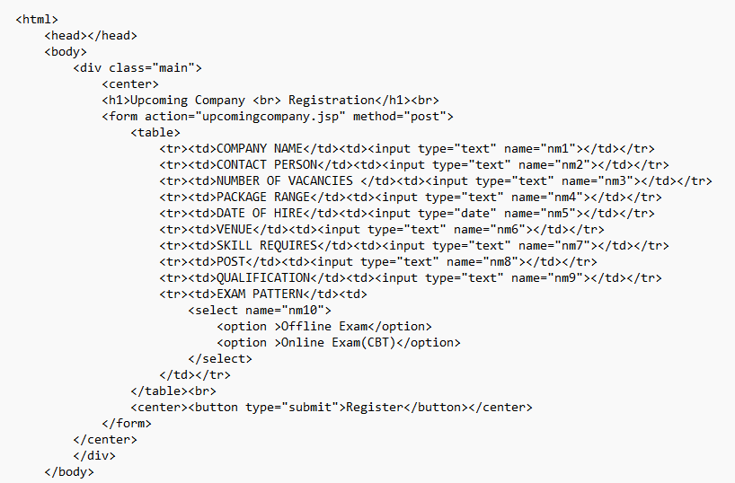

1. **CONCLUSION**

The Online Hotel Booking System project aims to provide a user-friendly and secure platform for users to search and book hotel rooms online. The system design and architecture have been carefully planned to ensure scalability, reliability, and maintainability.

The system's security measures, including authentication, authorization, data encryption, and regular updates, will protect user data and prevent unauthorized access.

The project's scope, timelines, and budget have been clearly defined, and the system's modules, including user management, hotel management, room management, search, booking, and payment, have been designed to meet the project's requirements.

Overall, the Online Hotel Booking System project has the potential to provide a seamless and secure booking experience for users, while also providing a robust and scalable platform for hotel administrators to manage their listings and booking s.

**Future Enhancements:**

1. Integration with external systems : Integrate the system with external systems, such as property management systems or revenue management systems.

2. Mobile app development : Develop mobile apps for iOS and Android to provide a seamless booking experience for users on-the-go.

3. Artificial intelligence and machine learning : Implement AI and ML algorithms to provide personalized recommendations and improve the booking experience.

**ADVANTAGES:**

The project is identified by the merits of the system offered to the user. The merits of this project are as follows: -

* It’s a web-enabled project.
* This project offers user to enter the data through simple and interactive forms. This is very helpful for the user to enter the desired information through so much simplicity.
* The user is mainly more concerned about the validity of the data, whatever he is entering. There are checks on every stages of any new creation, data entry or updating so that the user cannot enter the invalid data, which can create problems at later date.
* Sometimes the user finds in the later stages of using project that he needs to update some of the information that he entered earlier. There are options for him by which he can update the records. Moreover there is restriction for his that he cannot change the primary data field. This keeps the validity of the data to longer extent.
* User is provided the option of monitoring the records he entered earlier. He can see the desired records with the variety of options provided by him.
* From every part of the project the user is provided with the links through framing so that he can go from one option of the project to other as per the requirement. This is bound to be simple and very friendly as per the user is concerned. That is, we can sit that the project is user friendly which is one of the primary concerns of any good project.
* Data storage and retrieval will become faster and easier to maintain because data is stored in a systematic manner and in a single database.
* Decision making process would be greatly enhanced because of faster processing of information since data collection from information available on computer takes much less time then manual system.
* Easier and faster data transfer through latest technology associated with the computer and communication.
* Through these features it will increase the efficiency, accuracy and transparency.

**DISADVANTAGES:**

There are some limitations for the current system to which solutions can be provided as a future development:

1. The system is not configured for multi- users at this time. The concept of transaction can be used to achieve this.

2. The Website is not accessible to everyone. It can be deployed on a web server so that everybody who is connected to the Internet can use it.

3. Credit Card validation is not done. Third party proprietary software can be used for validation check.

**BIBLIOGRAPHY**

* **FOR SQL 10 g INSTALLATION**

<https://www.oracle.com/middleware/technologies/appserver-1012.html>

* **FOR DEPLOYMENT AND PACKING ON SERVER**

<https://code.visualstudio.com/download>

* **FOR APACHE TOMCAT SERVER**

<https://tomcat.apache.org/download-10.cgi>